**FIFA Laws of the Game 2014-15**

**Field surface**

Matches may be played on natural or artificial surfaces, according to the rules of the competition

The colour of artificial surfaces must be green.

Where artificial surfaces are used in either competition matches between representative teams of member associations affiliated to FIFA or international club competition matches, the surface must meet the requirements of the FIFA Quality Concept for Football Turf or the International Artificial Turf Standard, unless special dispensation is given by FIFA.

**Field markings**

The field of play must be rectangular and marked with lines. These lines belong to the areas of which they are boundaries.

The two longer boundary lines are called touch lines. The two shorter lines are called goal lines.

The field of play is divided into two halves by a halfway line, which joins the midpoints of the two touch lines.

The centre mark is indicated at the midpoint of the halfway line. A circle with a radius of 9.15 m (10 yds) is marked around it.

Marks may be made off the field of play, 9.15 m (10 yds) from the corner arc and at right angles to the goal lines and the touch lines, to ensure that defending players retreat this distance when a corner kick is being taken.

**Dimensions**

The length of the touch line must be greater than the length of the goal line.

Length (touch line):

* minimum 90 m (100 yds)
* maximum 120 m (130 yds)

Width (goal line):

* minimum 45 m (50 yds)
* maximum 90 m (100 yds)

All lines must be of the same width, which must be not more than 12 cm (5 ins).

**International matches**

Length:

* minimum 100 m (110 yds)
* maximum 110 m (120 yds)

Width:

* minimum 64 m (70 yds)
* maximum 75 m (80 yds)

**The goal area**

Two lines are drawn at right angles to the goal line, 5.5 m (6 yds) from the inside of each goalpost. These lines extend into the field of play for a distance of 5.5 m (6 yds) and are joined by a line drawn parallel with the goal line. The area bounded by these lines and the goal line is the goal area.

Two lines are drawn at right angles to the goal line, 16.5 m (18 yds) from the inside of each goalpost. These lines extend into the field of play for a distance of 16.5 m (18 yds) and are joined by a line drawn parallel with the goal line. The area bounded by these lines and the goal line is the penalty area.

Within each penalty area, a penalty mark is made 11 m (12 yds) from the midpoint between the goalposts and equidistant to them.

An arc of a circle with a radius of 9.15 m (10 yds) from the centre of each penalty mark is drawn outside the penalty area.

**Flagposts**

A flagpost, not less than 1.5 m (5 ft) high, with a non-pointed top and a flag must be placed at each corner.

Flagposts may also be placed at each end of the halfway line, not less than 1 m (1 yd) outside the touch line.

**The corner arc**

A quarter circle with a radius of 1 m (1 yd) from each corner flagpost is drawn inside the field of play.

**Goals**

A goal must be placed on the centre of each goal line.

A goal consists of two upright posts equidistant from the corner flagposts and joined at the top by a horizontal crossbar. The goalposts and crossbar must be made of wood, metal or other approved material. They must be square, rectangular, round or elliptical in shape and must not be dangerous to players.

The distance between the posts is 7.32 m (8 yds) and the distance from the lower edge of the crossbar to the ground is 2.44 m (8 ft).

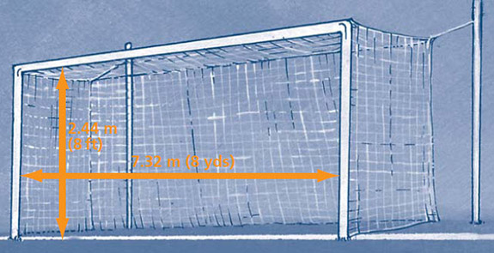

The position of the goalposts in relation to the goal line must be according to the graphics below.

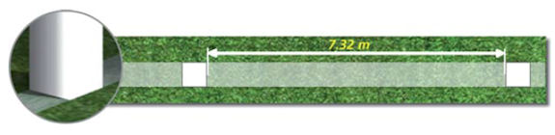

If the shape of the goalposts is square (viewed from above), the sides must be parallel or perpendicular to the goal line. The sides of the crossbar must be parallel or perpendicular to the field plane.

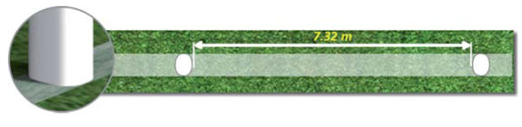

If the shape of the goalposts is elliptical (viewed from above), the longest axis must be perpendicular to the goal line. The longest axis of the crossbar must be parallel to the field plane.

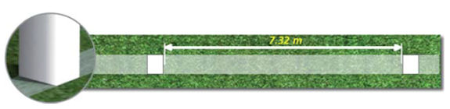

If the shape of the goalposts is rectangular (viewed from above), the longest side must be perpendicular to the goal line. The longest side of the crossbar must be parallel to the field plane.

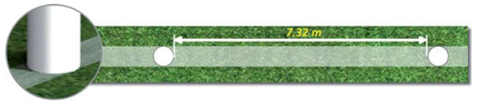

Both goalposts and the crossbar have the same width and depth, which do not exceed 12 cm (5 ins). The goal lines must be of the same width as the goalposts and the crossbar. Nets may be attached to the goals and the ground behind the goal, provided that they are properly supported and do not interfere with the goalkeeper.

The goalposts and crossbars must be white

**Safety**

Goals must be anchored securely to the ground. Portable goals may only be used if they satisfy this requirement.

**The field of play**

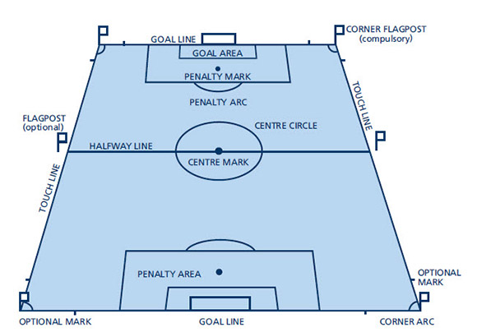

**Corner flagpost**

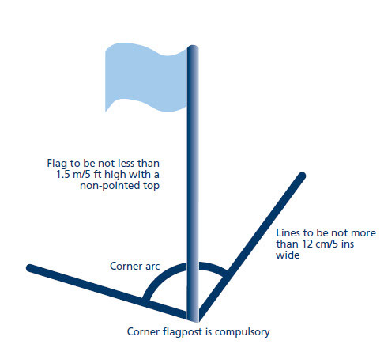

**Metric measurements**

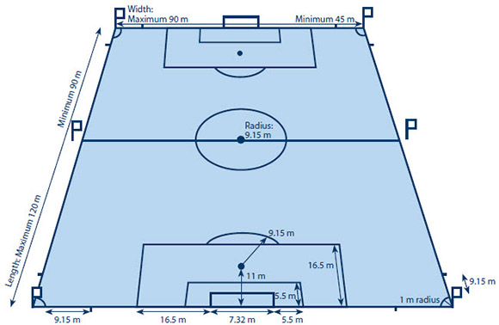

**Imperial measurements**

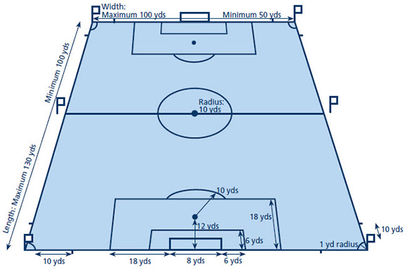

*Decisions of the International F.A. Board*

*Decision 1  
Where a technical area exists, it must meet the requirements approved by the International F.A. Board, which are contained in the section of this publication entitled The Technical Area.*

*Decision 2*

*Where goal-line technology (GLT) is used, modifications to the goal frame maybe allowed. They must be in accordance with the specifications stipulated in the FIFA Quality Programme for GLT and according to the above description, “Goals”.*